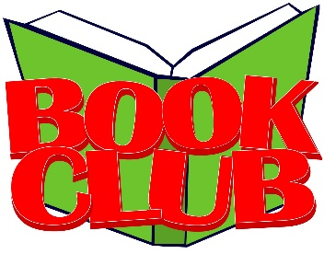
2019-20 Albion
Book Club Dates
Book Club is held after school
in the library.
September 17
Ban This Book by Alan Gratz
(realistic fiction)
October 22
Zero Day by Jan Gangsei
(mystery/thriller)
November 19
Bomb by Steve Sheinkin
(non-fiction/WWII)
December 17
The Afterlife of Holly Chase
by Cynthia Hand
(fantasy/paranormal)
January 28
Restart by Gordon Korman
(realistic fiction)
February 18
Warriors Don’t Cry by Melba Pattillo Beals
(non-fiction/memoir)
March 24
Uglies by Scott Westerfeld
(science fiction/dystopia)
April 21
Wolf Brother by Michelle Paver
(fantasy/adventure)
May 12
Four-Four-Two by Dean Hughes
(historical fiction)
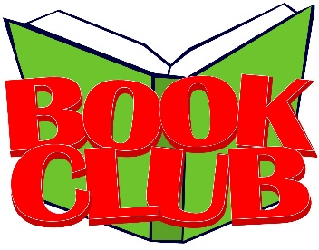
2019-20 Albion
Book Club Dates
Book Club is held after school
in the library.
September 17
Ban This Book by Alan Gratz
(realistic fiction)
October 22
Zero Day by Jan Gangsei
(mystery/thriller)
November 19
Bomb by Steve Sheinkin
(non-fiction/WWII)
December 17
The Afterlife of Holly Chase
by Cynthia Hand
(fantasy/paranormal)
January 28
Restart by Gordon Korman
(realistic fiction)
February 18
Warriors Don’t Cry by Melba Pattillo Beals
(non-fiction/memoir)
March 24
Uglies by Scott Westerfeld
(science fiction/dystopia)
April 21
Wolf Brother by Michelle Paver
(fantasy/adventure)
May 12
Four-Four-Two by Dean Hughes
(historical fiction)

2019-20 Albion
Book Club Dates
Book Club is held after school
in the library.
September 17
Ban This Book by Alan Gratz
(realistic fiction)
October 22
Zero Day by Jan Gangsei
(mystery/thriller)
November 19
Bomb by Steve Sheinkin
(non-fiction/WWII)
December 17
The Afterlife of Holly Chase
by Cynthia Hand
(fantasy/paranormal)
January 28
Restart by Gordon Korman
(realistic fiction)
February 18
Warriors Don’t Cry by Melba Pattillo Beals
(non-fiction/memoir)
March 24
Uglies by Scott Westerfeld
(science fiction/dystopia)
April 21
Wolf Brother by Michelle Paver
(fantasy/adventure)
May 12
Four-Four-Two by Dean Hughes
(historical fiction)

2019-20 Albion
Book Club Dates
Book Club is held after school
in the library.
September 17
Ban This Book by Alan Gratz
(realistic fiction)
October 22
Zero Day by Jan Gangsei
(mystery/thriller)
November 19
Bomb by Steve Sheinkin
(non-fiction/WWII)
December 17
The Afterlife of Holly Chase
by Cynthia Hand
(fantasy/paranormal)
January 28
Restart by Gordon Korman
(realistic fiction)
February 18
Warriors Don’t Cry by Melba Pattillo Beals
(non-fiction/memoir)
March 24
Uglies by Scott Westerfeld
(science fiction/dystopia)
April 21
Wolf Brother by Michelle Paver
(fantasy/adventure)
May 12
Four-Four-Two by Dean Hughes
(historical fiction)

