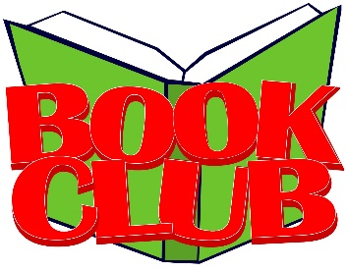
2017-18 Albion
Book Club Dates
Book Club is held after school
in the library.
September 19
The Scourge by Jennifer A. Nielsen
(adventure)
October 17
The Boy Who Harnessed the Wind
by William Kamkwamba
(non-fiction)
November 28
Scythe by Neal Shusterman
(science fiction/dystopian)
December 18
Raymie Nightingale by Kate DiCamillo
(realistic fiction)
January 23
Undefeated by Steve Sheinkin
(non-fiction)
February 20
Scar Island by Dan Gemeinhart
(adventure)
March 20
The Inquisitor’s Tale: Or the Three Magical Children and Their Holy Dog
by Adam Gidwitz
(fantasy)
April 17
Salt to the Sea by Ruta Sepetys
(historical fiction)
May 15
The Forgetting by Sharon Cameron
(science fiction/dystopian)
2017-18 Albion
Book Club Dates
Book Club is held after school
in the library.
September 19
The Scourge by Jennifer A. Nielsen
(adventure)
October 17
The Boy Who Harnessed the Wind
by William Kamkwamba
(non-fiction)
November 28
Scythe by Neal Shusterman
(science fiction/dystopian)
December 18
Raymie Nightingale by Kate DiCamillo
(realistic fiction)
January 23
Undefeated by Steve Sheinkin
(non-fiction)
February 20
Scar Island by Dan Gemeinhart
(adventure)
March 20
The Inquisitor’s Tale: Or the Three Magical Children and Their Holy Dog
by Adam Gidwitz
(fantasy)
April 17
Salt to the Sea by Ruta Sepetys
(historical fiction)
May 15
The Forgetting by Sharon Cameron
(science fiction/dystopian)
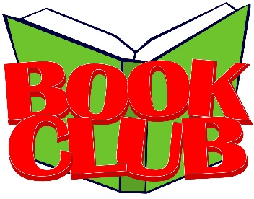
2017-18 Albion
Book Club Dates
Book Club is held after school
in the library.
September 19
The Scourge by Jennifer A. Nielsen
(adventure)
October 17
The Boy Who Harnessed the Wind
by William Kamkwamba
(non-fiction)
November 28
Scythe by Neal Shusterman
(science fiction/dystopian)
December 18
Raymie Nightingale by Kate DiCamillo
(realistic fiction)
January 23
Undefeated by Steve Sheinkin
(non-fiction)
February 20
Scar Island by Dan Gemeinhart
(adventure)
March 20
The Inquisitor’s Tale: Or the Three Magical Children and Their Holy Dog
by Adam Gidwitz
(fantasy)
April 17
Salt to the Sea by Ruta Sepetys
(historical fiction)
May 15
The Forgetting by Sharon Cameron
(science fiction/dystopian)
2017-18 Albion
Book Club Dates
Book Club is held after school
in the library.
September 19
The Scourge by Jennifer A. Nielsen
(adventure)
October 17
The Boy Who Harnessed the Wind
by William Kamkwamba
(non-fiction)
November 28
Scythe by Neal Shusterman
(science fiction/dystopian)
December 18
Raymie Nightingale by Kate DiCamillo
(realistic fiction)
January 23
Undefeated by Steve Sheinkin
(non-fiction)
February 20
Scar Island by Dan Gemeinhart
(adventure)
March 20
The Inquisitor’s Tale: Or the Three Magical Children and Their Holy Dog
by Adam Gidwitz
(fantasy)
April 17
Salt to the Sea by Ruta Sepetys
(historical fiction)
May 15
The Forgetting by Sharon Cameron
(science fiction/dystopian)

